Pressure switch for high electrical loads

Klingenberg, February 2018.
WIKA has extended its family of pressure switches with a heavy-duty instrument for machine building. The model PSM-520 can switch electrical loads of up to AC 230 V/10 A.

The robust instrument has been designed, in particular, for use in the pump and compressor industry. The switch point can be individually set on site, while a protection cap prevents any accidental alteration.

The model PSM-520 can be delivered with setting ranges from
-0.4 … +7 bar to 6 … 30 bar. It operates with a non-repeatability of the switch point of ≤ 2 % of span.

Number of characters: 541
Key word: PSM-520

Manufacturer:
WIKA Alexander Wiegand SE & Co. KG
Alexander-Wiegand-Straße 30
63911 Klingenberg/Germany
Tel. +49 9372 132-0
Fax +49 9372 132-406
vertrieb@wika.com
www.wika.de

WIKA company photograph:
WIKA pressure switch model PSM-520, for high electrical loads

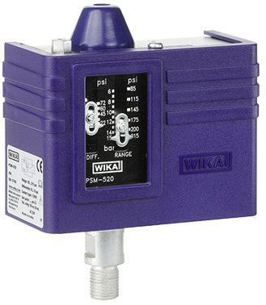

Edited by:
WIKA Alexander Wiegand SE & Co. KG
André Habel Nunes
Marketing Services
Alexander-Wiegand-Straße 30
63911 Klingenberg/Germany
Tel. +49 9372 132-8010
Fax +49 9372 132-8008010
andre.habel-nunes@wika.com
www.wika.de

WIKA press release 03/2018

