Fully certified
safety control for cranes

Klingenberg, March 2020.- For cranes that are not at risk of tipping and for lifting systems, with the ELMS1, WIKA offers a fully certified safety control to protect against overload. This new product combines safety electronics, software and safety force transducers. ELMS1 is also the world's first dual hoist system approved by the German social accident insurance association (DGUV).

The new solution eliminates the need for time-consuming individual certifications, as is otherwise necessary with comparable systems. The ELMS1 safety control is certified in accordance with DIN EN ISO 13849 with performance level “d”. Its central module enables the total load of up to eight redundant force transducers to be automatically balanced. With the dual hoist system, up to four containers can be lifted at the same time. ELMS1 warns of switching thresholds and switches off in the event of an overload.

The new safety control from WIKA is equally suitable for installation in new or existing systems. ELMS1 has various analogue and digital inputs and outputs. The system is also available with different communication protocols such as CANopen and PROFIBUS.

Number of characters: 1.129
Key word: ELMS1

Manufacturer:
WIKA Alexander Wiegand SE & Co. KG
Alexander-Wiegand-Straße 30
63911 Klingenberg/Germany
Tel. +49 9372 132-5049
Fax +49 9372 132-406
vertrieb@wika.com
www.wika.de

WIKA company photograph:

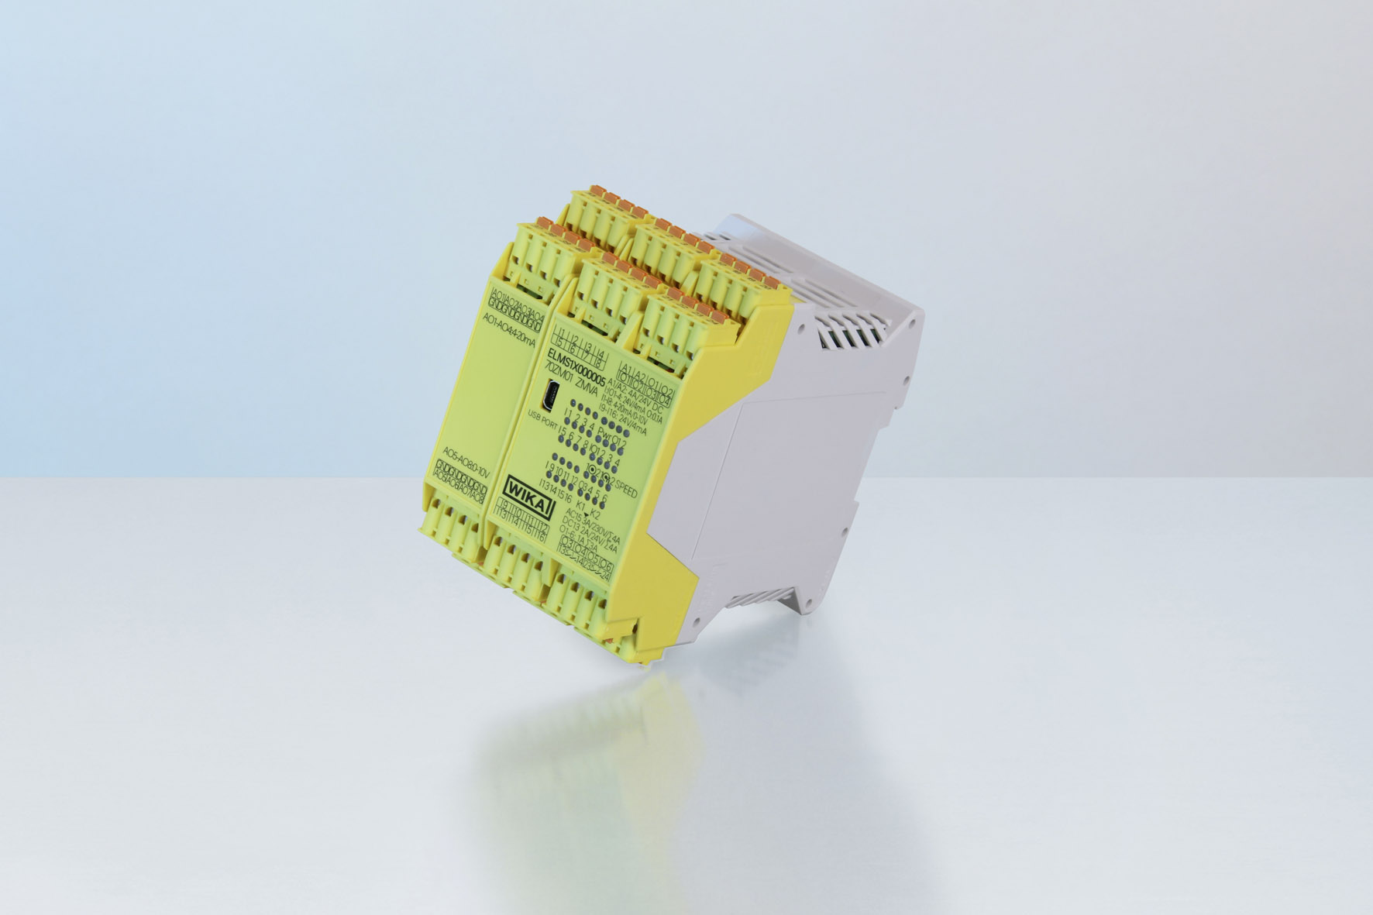

Typ ELMS1

Edited by:
WIKA Alexander Wiegand SE & Co. KG
André Habel Nunes
Marketing Services
Alexander-Wiegand-Straße 30
63911 Klingenberg/Germany
Tel. +49 9372 132-8010
Fax +49 9372 132-8008010
andre.habel-nunes@wika.com
www.wika.de

WIKA press release

