New S-20 pressure transmitter
is UL listed

Klingenberg, September 2014.
Success for the new S-20 pressure transmitter from WIKA: After being tested by the American certification company Underwriters Laboratories Inc. (UL) the instrument, which is available in numerous variants, is listed to applicable UL standards and requirements by UL.

The globally accepted UL listing facilitates the use of the S-20 in all major markets. WIKA has developed the new measuring instrument for general industrial applications. It is available with all the connections and output signals expected in the market and in different accuracy classes. Customer-specific solutions are also possible.

The S-20 has been designed for demanding applications and measures precisely, even under extreme conditions. It features international approvals and is available with short lead times in all variants.

Number of characters: 873
Key words: S-20 with cULus logo

Manufacturer:
WIKA Alexander Wiegand SE & Co. KG
Alexander-Wiegand-Straße 30
63911 Klingenberg/Germany
Tel. +49 9372 132-0
Fax: +49 9372 132-406
vertrieb@wika.com
www.wika.com

WIKA company photograph:
Pressure transmitter S-20 with cULus logo

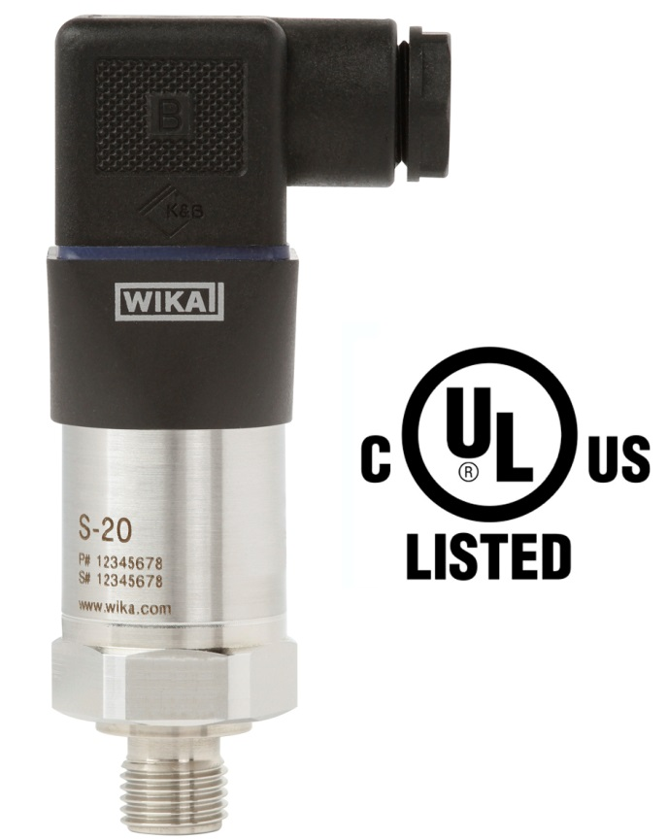

Edited by:
WIKA Alexander Wiegand SE & Co. KG
André Habel Nunes
Marketing Services
Alexander-Wiegand-Straße 30
63911 Klingenberg/Germany
Tel. +49 9372 132-8010
Fax: +49 9372 132-8008010
andre.habel-nunes@wika.com
www.wika.com

WIKA press release 09/2014

