“Full Assessment” certificate − also for the new version of the T32.xS

Klingenberg, April 2015.

The T32.xS temperature transmitter with HART® protocol from WIKA is now available in a revised version. TÜV Rheinland has renewed the certification for the universal instrument in accordance with the current standard for use in safety-critical applications up to SIL level 3 (“Full Assessment”).

The new transmitter version, amongst other features, has been given optimised sensor-break diagnostics, an update to the HART®-specific measured value processing and an extended clamping range. For easier installation when it is already fitted, the sensor connection diagram has been printed onto the upper side of the instrument.

On its market launch in 2010, the T32.xS was the first temperature transmitter which had been developed and certified in accordance with IEC61508. Since then, there have been well over 100,000 instruments in successful operation.

Number of characters: 855
Key words: Temperature transmitter T32.xS

Manufacturer:
WIKA Alexander Wiegand SE & Co. KG
Alexander-Wiegand-Straße 30
63911 Klingenberg/Germany
Tel. +49 9372 132-0
Fax +49 9372 132-406
vertrieb@wika.com
www.wika.com

WIKA company photograph:
WIKA temperature transmitter T32.xS with HART® protocol

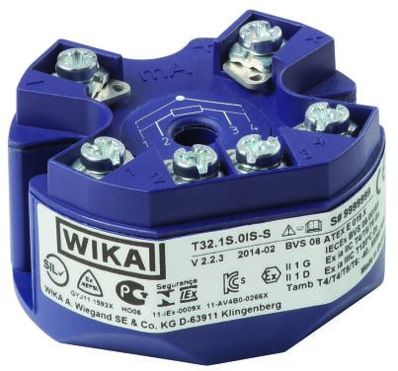

Edited by:
WIKA Alexander Wiegand SE & Co. KG
André Habel Nunes
Marketing Services
Alexander-Wiegand-Straße 30
63911 Klingenberg/Germany
Tel. +49 9372 132-8010
Fax +49 9372 132-8008010
andre.habel-nunes@wika.com
www.wika.com

WIKA press release 10/2015

